EX NO: 8
POWER SPECTRAL DENSITY (PSD) ANALYSIS OF PHASE MODULATED (PM) SIGNALS USING MATLAB
Objectives
i) To generate a Phase Modulated (PM) signal in MATLAB using specified carrier and message
signal parameters.
PROGRAMMING CODE:
clc;
clear;
close all;

% Given Parameters
Am = 1; % Message signal amplitude
Ac = 2; % Carrier signal amplitude
fm = 100; % Message frequency in Hz
fc = 1000; % Carrier frequency in Hz
kp = pi/2; % Phase sensitivity in radians/volt

% Time vector
fs = 100000; % Sampling frequency
t = 0:1/fs:0.02; % Time duration

% Generate Message Signal
m = Am * cos(2*pi*fm*t);

% Generate Carrier Signal
c = Ac * cos(2*pi*fc*t);

% Generate Phase Modulated Signal
s = Ac * cos(2*pi*fc*t + kp*m);

% Plot Signals
figure;

subplot(3,1,1);
plot(t,m);
title('Message Signal');
xlabel('Time (s)');
ylabel('Amplitude');
grid on;

subplot(3,1,2);
plot(t,c);
title('Carrier Signal');
xlabel('Time (s)');
ylabel('Amplitude');
grid on;

subplot(3,1,3);
plot(t,s);
title('Phase Modulated (PM) Signal');
xlabel('Time (s)');
ylabel('Amplitude');
grid on;
OUTPUTS:
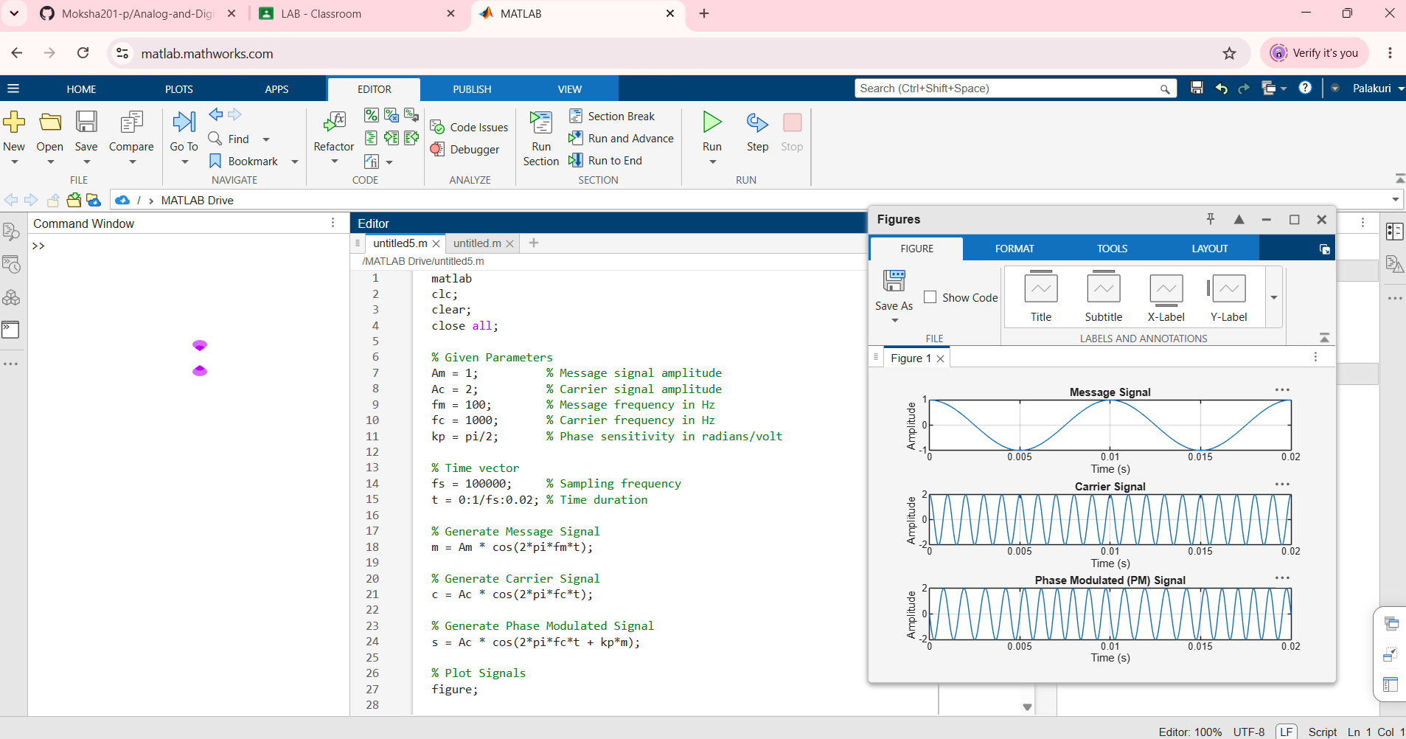
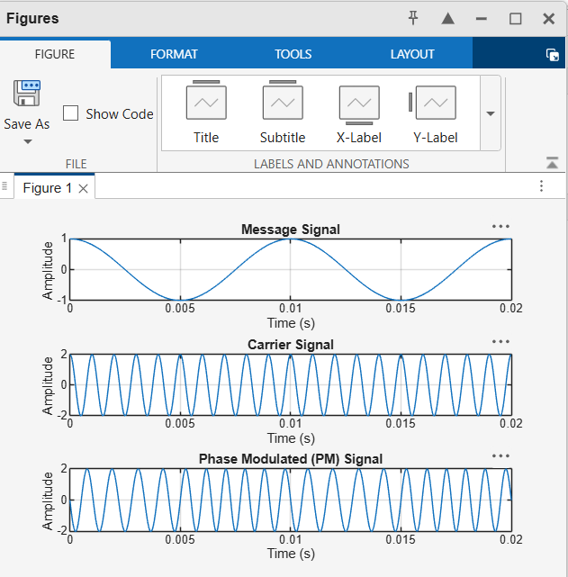
OBJECTIVE:
ii) To compute the frequency spectrum of the PM signal using the Fast Fourier Transform (FFT).
PROGRAMMING CODE:
clc;
clear;
close all;

% Given Parameters
Am = 1; % Message signal amplitude
Ac = 2; % Carrier signal amplitude
fm = 100; % Message frequency in Hz
fc = 1000; % Carrier frequency in Hz
kp = pi/2; % Phase sensitivity in radians/volt

% Sampling Parameters
fs = 10000; % Sampling frequency
T = 0.1; % Duration in seconds
t = 0:1/fs:T-1/fs;

% Generate Message Signal
m = Am * cos(2*pi*fm*t);

% Generate Carrier Signal
c = Ac * cos(2*pi*fc*t);

% Generate PM Signal
s = Ac * cos(2*pi*fc*t + kp*m);

% Compute FFT
N = length(s);
S = fft(s);
S_mag = abs(S)/N;

% Single-sided spectrum
P1 = S_mag(1:N/2+1);
P1(2:end-1) = 2*P1(2:end-1);

% Frequency Axis
f = fs*(0:N/2)/N;

% Plot Message Signal
figure;

subplot(3,1,1);
plot(t,m);
title('Message Signal');
xlabel('Time (s)');
ylabel('Amplitude');
grid on;

% Plot PM Signal
subplot(3,1,2);
plot(t,s);
title('Phase Modulated Signal');
xlabel('Time (s)');
ylabel('Amplitude');
grid on;

% Plot Frequency Spectrum
subplot(3,1,3);
plot(f,P1);
title('Frequency Spectrum of PM Signal Using FFT');
xlabel('Frequency (Hz)');
ylabel('Magnitude');
xlim([0 2000]);
grid on;
OUTPUTS:
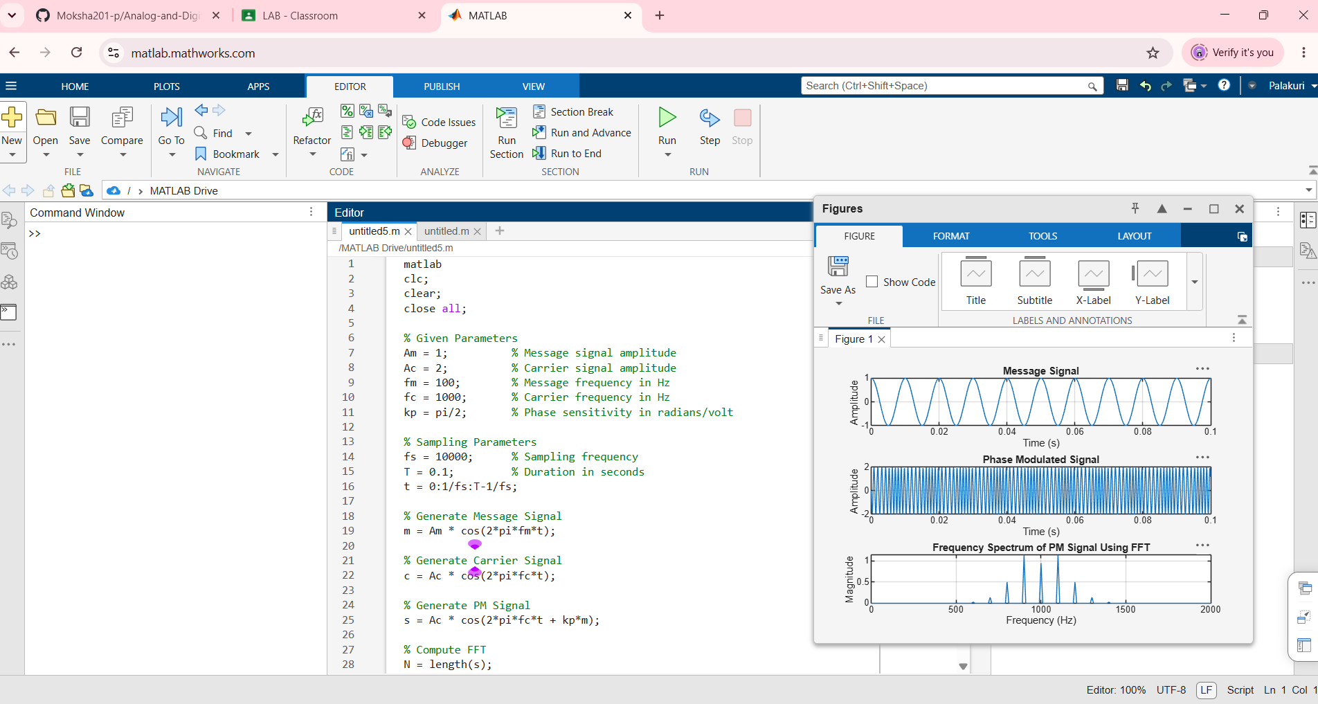
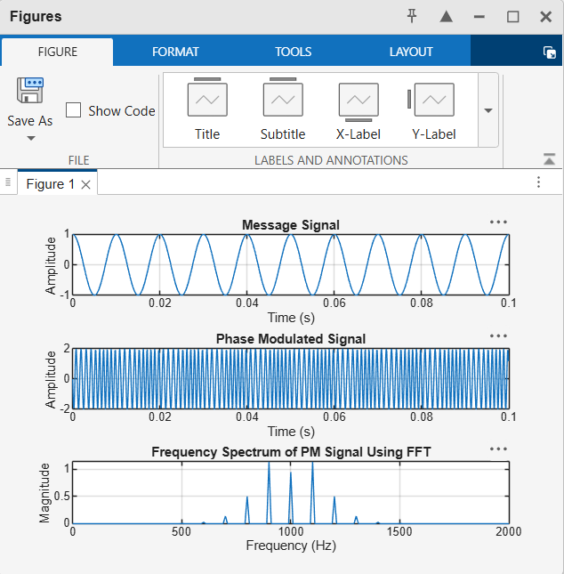

OBJECTIVE:
iii) To calculate and plot the Power Spectral Density (PSD) of the PM signal using MATLAB.
PROGRAMMING CODE:
matlab
clc;
clear;
close all;

% Given Parameters
Am = 1; % Message signal amplitude
Ac = 2; % Carrier signal amplitude
fm = 100; % Message frequency in Hz
fc = 1000; % Carrier frequency in Hz
kp = pi/2; % Phase sensitivity in radians/volt

% Sampling Parameters
fs = 10000; % Sampling frequency in Hz
T = 0.1; % Duration in seconds
t = 0:1/fs:T-1/fs;

% Generate Message Signal
m = Am * cos(2*pi*fm*t);

% Generate PM Signal
s = Ac * cos(2*pi*fc*t + kp*m);

% Calculate Power Spectral Density using Welch's Method
[pxx, f] = pwelch(s, [], [], [], fs);

% Plot Message Signal
figure;

subplot(3,1,1);
plot(t, m);
title('Message Signal');
xlabel('Time (s)');
ylabel('Amplitude');
grid on;

% Plot PM Signal
subplot(3,1,2);
plot(t, s);
title('Phase Modulated (PM) Signal');
xlabel('Time (s)');
ylabel('Amplitude');
grid on;

% Plot Power Spectral Density
subplot(3,1,3);
plot(f, 10*log10(pxx + eps));
title('Power Spectral Density of PM Signal');
xlabel('Frequency (Hz)');
ylabel('PSD (dB/Hz)');
xlim([0 2000]);
grid on;
OUTPUT:
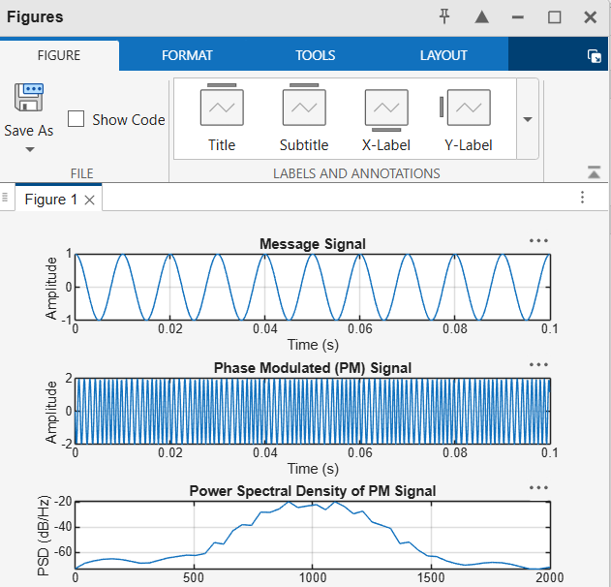

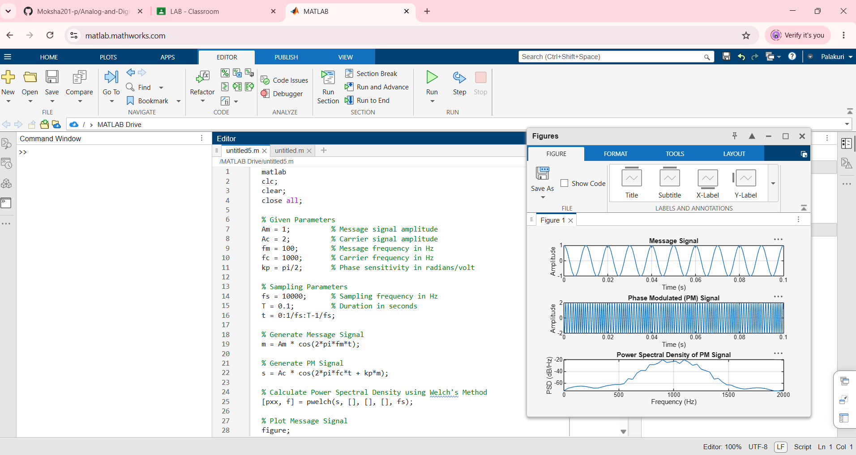

OBJECTIVE
iv) To identify the carrier component and sideband frequencies present in the PM spectrum.
PROGRAMMING CODE:
clc;
clear;
close all;

% Given Parameters
Am = 1; % Message signal amplitude
Ac = 2; % Carrier signal amplitude
fm = 100; % Message frequency in Hz
fc = 1000; % Carrier frequency in Hz
kp = pi/2; % Phase sensitivity in radians/volt

% Sampling Parameters
fs = 10000; % Sampling frequency
T = 0.1; % Duration in seconds
t = 0:1/fs:T-1/fs;

% Generate Message Signal
m = Am * cos(2*pi*fm*t);

% Generate PM Signal
s = Ac * cos(2*pi*fc*t + kp*m);

% Compute FFT
N = length(s);
S = fft(s);
P2 = abs(S)/N;

% Single-sided amplitude spectrum
P1 = P2(1:N/2+1);
P1(2:end-1) = 2*P1(2:end-1);

% Frequency vector
f = fs*(0:N/2)/N;

% Find Peaks in Spectrum
[pks, locs] = findpeaks(P1, f, ...
'MinPeakHeight', 0.05, ...
'MinPeakDistance', 50);

% Display Peak Frequencies
fprintf('Carrier Frequency = %d Hz\n', fc);
fprintf('Message Frequency = %d Hz\n\n', fm);
fprintf('Identified Carrier and Sideband Frequencies:\n');

for i = 1:length(locs)
fprintf('Frequency = %.2f Hz, Amplitude = %.4f\n', ...
locs(i), pks(i));
end

% Plot Frequency Spectrum
figure;
plot(f, P1, 'b', 'LineWidth', 1.5);
hold on;
plot(locs, pks, 'ro', 'MarkerFaceColor', 'r');

title('PM Spectrum: Carrier and Sidebands');
xlabel('Frequency (Hz)');
ylabel('Amplitude');
xlim([500 1500]);
grid on;
legend('PM Spectrum', 'Detected Peaks');
OUTPUTS:
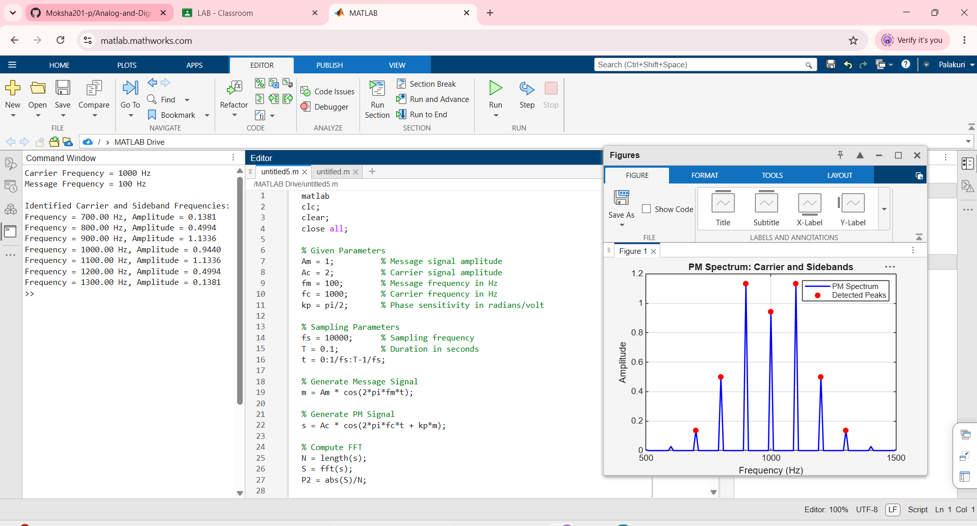

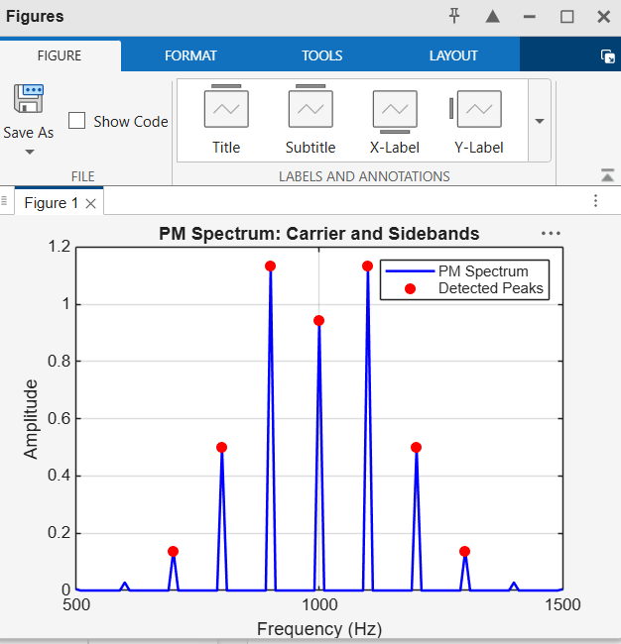
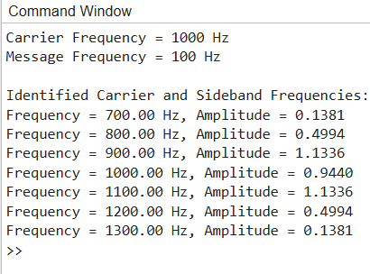

OBJECTIVE:
v) To analyze the effect of phase modulation on the spectral distribution and bandwidth of the transmitted signal.
PROGRAMMING CODE:
clc;
clear;
close all;

% Given Parameters
Am = 1; % Message signal amplitude
Ac = 2; % Carrier signal amplitude
fm = 100; % Message frequency in Hz
fc = 1000; % Carrier frequency in Hz
kp = pi/2; % Phase sensitivity in radians/volt

% Sampling Parameters
fs = 10000; % Sampling frequency in Hz
T = 0.1; % Duration in seconds
t = 0:1/fs:T-1/fs;

% Generate Message Signal
m = Am * cos(2*pi*fm*t);

% Calculate Phase Deviation
beta = kp * Am;

% Generate PM Signal
s = Ac * cos(2*pi*fc*t + kp*m);

% Calculate FFT
N = length(s);
S = fft(s);
P2 = abs(S)/N;

% Single-Sided Spectrum
P1 = P2(1:N/2+1);
P1(2:end-1) = 2*P1(2:end-1);

% Frequency Axis
f = fs*(0:N/2)/N;

% Find Significant Spectral Components
threshold = max(P1) * 0.01;
idx = find(P1 >= threshold);

% Calculate Approximate Bandwidth
if ~isempty(idx)
f_low = min(f(idx));
f_high = max(f(idx));
bandwidth = f_high - f_low;
else
f_low = 0;
f_high = 0;
bandwidth = 0;
end

% Display Results
fprintf('Carrier Frequency = %d Hz\n', fc);
fprintf('Message Frequency = %d Hz\n', fm);
fprintf('Phase Deviation = %.2f radians\n', beta);
fprintf('Lower Significant Frequency = %.2f Hz\n', f_low);
fprintf('Upper Significant Frequency = %.2f Hz\n', f_high);
fprintf('Approximate Bandwidth = %.2f Hz\n', bandwidth);

% Plot Message Signal
figure;

subplot(3,1,1);
plot(t,m);
title('Message Signal');
xlabel('Time (s)');
ylabel('Amplitude');
grid on;

% Plot PM Signal
subplot(3,1,2);
plot(t,s);
title('Phase Modulated Signal');
xlabel('Time (s)');
ylabel('Amplitude');
grid on;

% Plot Frequency Spectrum
subplot(3,1,3);
plot(f,P1,'b','LineWidth',1.2);
hold on;
yline(threshold,'r--','1% Threshold');
title('Spectral Distribution of PM Signal');
xlabel('Frequency (Hz)');
ylabel('Amplitude');
xlim([500 1500]);
grid on;
OUTPUTS:
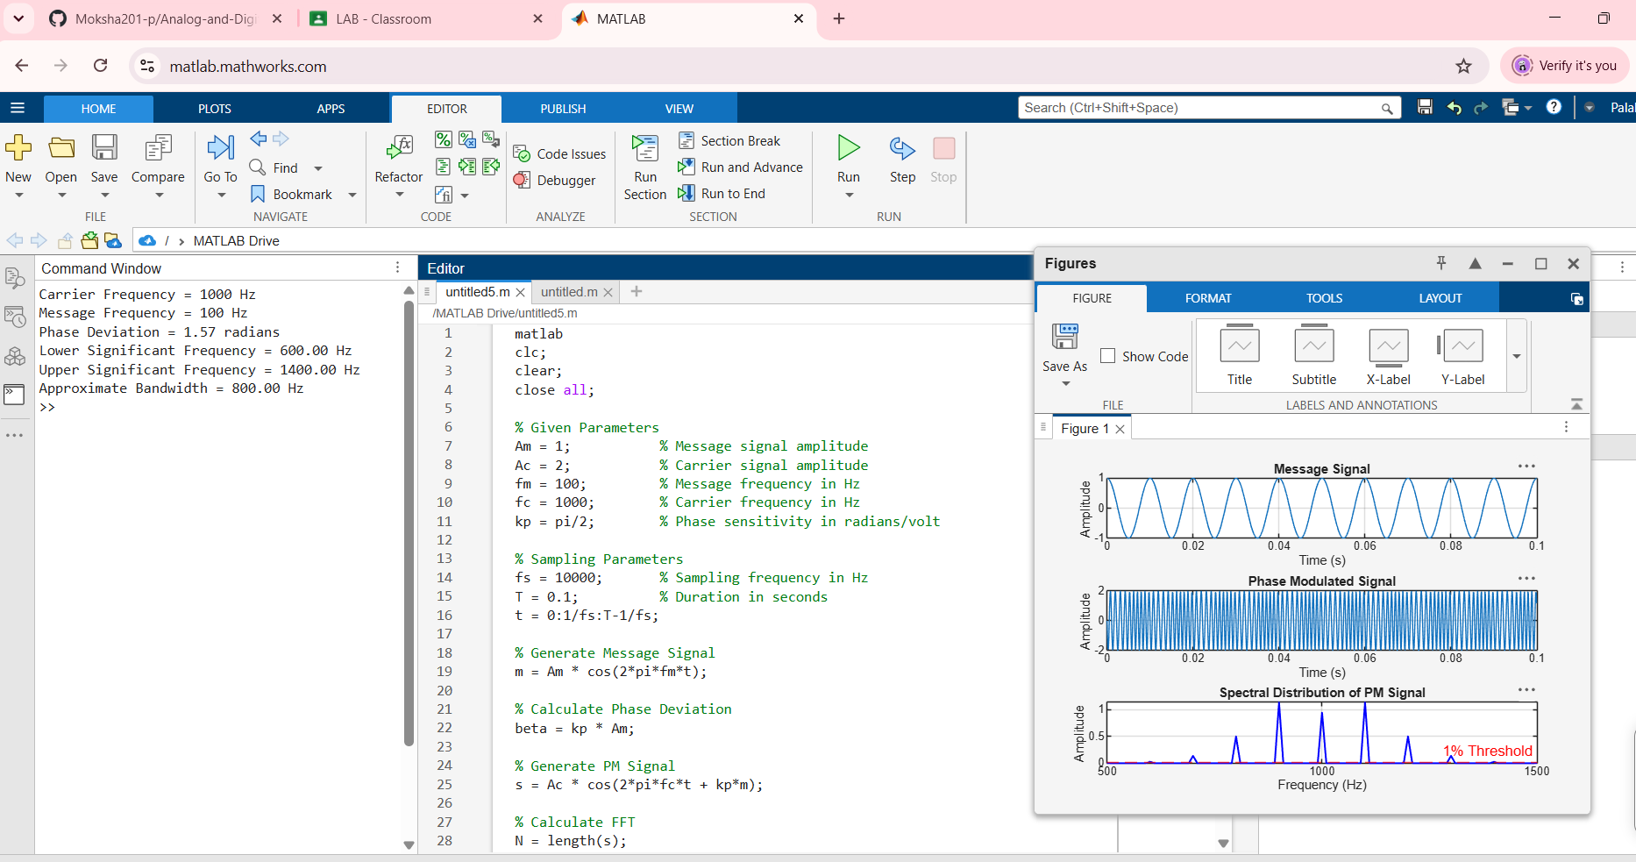

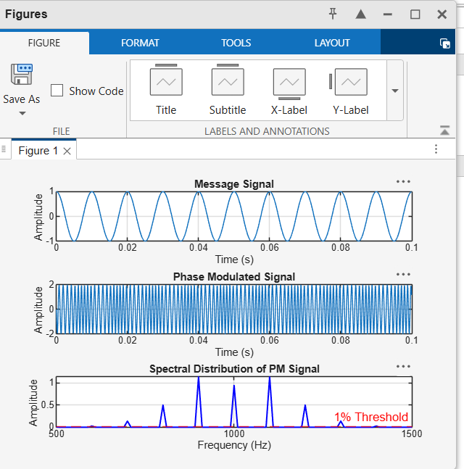
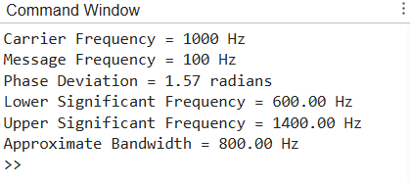
OBJECTIVE:
vi)To investigate the influence of modulation index on the Power Spectral Density characteristics of the PM signal.
PROGRAMMING CODE:
clc;
clear;
close all;

% Given Parameters
Am = 1; % Message signal amplitude
Ac = 2; % Carrier signal amplitude
fm = 100; % Message frequency in Hz
fc = 1000; % Carrier frequency in Hz
kp_values = [0.5 1 2 3]; % Phase sensitivity values in rad/V

% Sampling Parameters
fs = 10000; % Sampling frequency
T = 0.1; % Duration in seconds
t = 0:1/fs:T-1/fs;

% Generate Message Signal
m = Am*cos(2*pi*fm*t);

% Create Figure
figure;

for i = 1:length(kp_values)

% Calculate Modulation Index
beta = kp_values(i)*Am;

% Generate PM Signal
s = Ac*cos(2*pi*fc*t + kp_values(i)*m);

% Calculate PSD using Welch's Method
[pxx,f] = pwelch(s, [], [], [], fs);

% Plot PSD
subplot(2,2,i);
plot(f,10*log10(pxx + eps),'LineWidth',1.2);
title(['PM Signal PSD, Modulation Index = ',num2str(beta)]);
xlabel('Frequency (Hz)');
ylabel('PSD (dB/Hz)');
xlim([500 1500]);
grid on;

% Display Modulation Index
fprintf('Phase Sensitivity = %.2f rad/V, ',kp_values(i));
fprintf('Modulation Index = %.2f\n',beta);

end

sgtitle('Effect of Modulation Index on PM Signal PSD');
OUTPUTS:
